Title: Design and Implementation of an IoT-Enabled Hybrid Energy Management System for EV Charging Infrastructure with Simulation and Hardware Validation.

Authors: Dr. Sujith Kalluri, Mr. Jagadeeswara Chandra Bose Kamarajugadda, Mr. Sayyad Sameer, Mr. Ghantasala Jaswanth Kumar

Department of Electronics and Communication Engineering / Internet of Things SRM University AP, India
…………………………………………………………………………………………………………………..

Abstract—
An increasing number of electric vehicles requires better charging infrastructure systems are needed as the electric vehicles rising rapidly. However, the use of grids to support these systems will result in instability due to fluctuating loads and high operating and maintenance costs. Additionally, the grid will not be able to effectively integrate renewable energy sources due to inadequate real-time monitoring and coordination between these two systems. Existing systems are predominantly grid-dependent, which in turn leads to inefficient operation of and stress on the electric grids; furthermore, the proposed ‘Integrated systems’ are not yet operationally validated and still only exist in simulation format. This paper fills this gap by introducing an innovative hardware-based Internet of Things (IoT) – based hybrid energy management system (architecture) to be utilized at Electric Vehicle Charging Stations. At the heart of this proposed architecture is a smart Point of Common Coupling (PCC) that brings together solar photovoltaic generation, an Energy Storage System (ESS), and utility grid systems using a rule-based automation algorithm that dynamically prioritizes renewable energy sources for use at EV Charging Stations. Realtime monitoring, predictive control and remote management capabilities are enabled by a five-layer IoT architecture that consists of the following components: Sensor network, Edge processing, Cloud analytics and User dashboard.

To validate the proposed design, two methods were used: MATLAB/Simulink simulation and a comprehensive hardware prototype built from ESP32 microcontrollers, power converters, and an entire suite of sensors, with data aggregation via Node-RED. Experimental results indicate improved energy consumption, lower operational costs and increased stability of the grid; therefore, providing a roadmap for developing cost effective and sustainable charging infrastructure for electric vehicles.

Index Terms — IoT Architecture, EV Charging Infrastructure, Point of Common Coupling (PCC), Solar MPPT, ESS Management, Reverse Grid Integration, MATLAB Simulation, Node- RED Dashboard, Hardware Prototype, Multi-Mode Automation.

INTRODUCTION
The world’s transportation industry is in a state of change as it moves towards electricity to power its vehicles due to the need to cut back on carbon emissions from fossil fuels. Electric vehicles (EVs) have a lot of sales growing quickly because of improvements in battery technology, policies that support the growth of EVs and more consumers buying them. But the long-term sustainability and adoption of this new type of transportation rely heavily on having the right electric vehicle charging stations built. As they currently exist today, the vast majority (if not all) of the current EV charging stations require that electricity comes from the grid using” on-grid” or” grid-connected” systems. This creates a number of issues on utilities’ electric distribution systems including increasing peak electricity demand for utilities; generating large amounts of high-cost electricity, using high-priced, at-risk fossil fuel sources, and failing to take advantage of all the potential renewable energy resources available from the local cities, towns and electric customers. So, the way to resolve the shortcomings of these charging stations is to utilize local, distributed renewable energy generation (investing especially in solar photovoltaics) along with energy storage systems (ESS) attached to the EV charging station. The potential of this hybrid system to support a wider range of grid-independence, cost stability, and enhanced sustainability is promising. Simultaneously, the Internet of Things (IoT) offers the fundamental technological underpinning that will enable these hybrid energy sources to progress from passive loads to intelligent, networked smart gadgets. The functioning within an overarching smart grid environment. IoT enables Realtime monitoring, data-driven optimization and automation of the complex energy flows between sources, storage devices, and loads. Although the theoretical interoperability between renewables, storage and IoT’s ability to support smart charging is established in much of the literature, virtually no existing research has reported an actual implementation of this combined architecture as a whole (i.e., using an IoT having a combination of renewable energy, storage, and IoT) for charging of electric vehicles (EVs). Instead, much of the literature on the topic consists of published software models and algorithm studies that do not include a practical understanding of the integration of hardware components, communication reliability, sensor compatibility, and development of a complete, integrated layered architectural stack for an IoT-enabled hybrid energy management (HEM) system. This paper will help fill this gap by detailing the designs, simulations, and—most importantly—all hardware implementations of a novel and distinctive IoT-enabled hybrid energy management system for electric vehicle (EV) charging, this study will contribute to closing this gap.

In this paper, we will show the proposed and implemented five-layered architecture of IoT systems (from edge layer sensors/microcontrollers to cloud-based analytics and user-facing dashboards) all controlled by intelligent automation logic and centered around an electrical point of common coupling (PCC).A dynamic energy management system, Prototype model developed by [SRM University AP] offers intelligent energy management, controlling the dynamic flow of energy between solar photovoltaic (PV), energy storage systems (ESS), and the electric utility grid with an emphasis on utilizing renewable energy sources whenever feasible to lower operating costs and grid impact. Additionally, the system is capable of operating dual-mode (e.g., battery swap stations and direct current (DC) fast charging ports) thereby providing operational flexibility. First, the system design was validated through extensive simulations using MATLAB/Simulink, and then a fully functioning hardware prototype was built and tested using wireless microcontrollers, multiple sensors, power electronics converters, and integration with cloud-based connectivity to provide visualization using Node-RED. This research represents a major step forward from an initial idea or theoretical concept to a functional prototype. It offers an innovative and scalable option for developing low-cost, efficient, and environmentally friendly EV charging systems that are capable of supporting renewable energy integration into the grid while enhancing overall grid stability.

To close the gap between the theory of Hybrid Energy Management Systems (HEMS) and practice, this article outlines the development of a new IOT-based HEMS for electric vehicle (EV) charging station management and remote monitoring, including cloud integration and real-time data dashboard. We developed an entirely new five (5) layer IOT architecture to interconnect physical devices (sensors, IoT microcontroller, and Power Supply units) through network/edge devices, into the cloud for data aggregation/analytics, and then to the final application layer for user interface/system visualization. The backbone of this system is the intelligent energy control logic located at the dynamically controlled PCC, which acts as the brain of the system. The PCC’s automation algorithm utilizes operational rules to continuously and dynamically manage the flow of energy between three key sources: solar PVs, energy storage systems (ESS), and the utility grid; utilizing load demand, state-of-charge (SOC) limits, and real-time energy availability to determine energy supply priorities for maximum use of free solar energy, optimal use of stored capacity, and minimum use of economically viable utility grid power; and a special reverse power flow capability that permits excess renewable energy to reverse-feed into the utility grid, turning the charging station into a prosumer. Two types of EV refueling models provide evidence of the adaptable nature of a system with respect to its area of operation as well as its configuration; i.e., DC Fast Charging (DCFC) stations and Battery Swapping Stations (BSS).

The dual-load concept demonstrates that architecture is flexible to meet various business models and requirements from users but still operates within the same management framework when both supply types are being used.
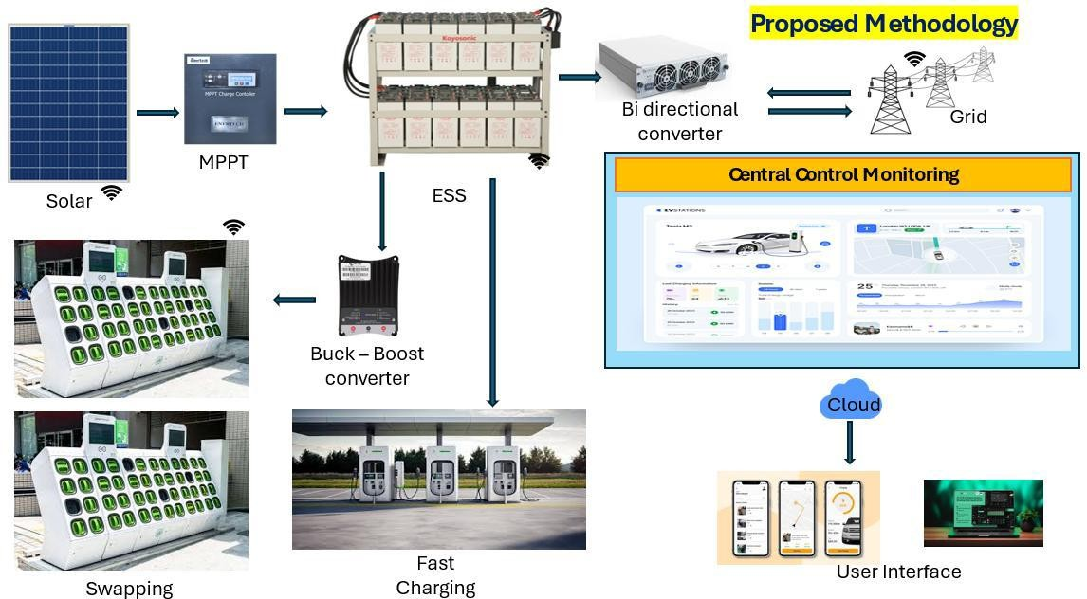
Fig: 1. High-level system overview of the IoT-enabled hybrid EV charging architecture.

The validation of the architecture’s performance will be accomplished by a combination of methods, including developing a detailed simulation in MATLAB/Simulink to design, test, and optimize the energy logic of the system and its performance metrics based upon the performance metrics associated with PCC (Point of Common Coupling) operating throughout the operational scenarios of the system. Important simulation results, including dynamic power sharing and ESS state-of-charge profiles, confirm the expected performance characteristics and stability of the proposed control system. The second and most important element of validation will be to transition the simulation to a fully functional prototype. This prototype features a complete set of functional devices consisting of ESP32 microcontrollers for data acquisition and control, an extensive range of sensors (voltage, current, and temperature), all necessary power electronics (DC-DC boost converters, inverters) and lead-acid batteries to represent the ESS. The hardware components are fully integrated to a cloud backend, through IoT services so that we can monitor them remotely and control them using real time dashboards developed in Node-RED, as seen in the dashboard interface. The comparison of the predicted energy flows of the simulated model versus the actual energy flows collected from the physical prototype validates the model’s accuracy and shows that this design can be used to implement this system in the real world. This project fills a critical research gap by moving forward from the early, theoretical phase of energy simulation to a confirmed, hardware-based prototype research demonstration. It provides a complete, scalable and practical model for installing next generation EV charging infrastructure that is not only intelligent, efficient, and economically viable; but also supports the electric grid and facilitates the transition to a fully electric, renewable energy transportation system.

LITERATURE SURVEY
Research into smart charging infrastructure for electric vehicles (EVs) has increased as the number of EVs available worldwide has ballooned. However, there are still major gaps between theoretical designs for systems that could be deployed with economic viability and what is being done to date. While the existing literature contains a considerable amount of information about the challenges of EV’s potential effect on grid instability, high operating costs and impact on the environment when recharged with electricity generated by fossil fuels [1-3], IoT (Internet of Things) based solutions have been proposed to enable real time monitoring and predictively scheduled charging of EVs [9, 10]; yet, once again the various architectural implementations are fragmented such that they provide solutions only for isolated issues such as residential charging interface design [17] or stand-alone battery monitoring [10], thus lacking a cohesive methodology/framework that integrates the entire energy value chain from generation through to end-use. Studies of renewable sources’ integration (e.g. PV predictive Event Scheduled Storage Management) [14] and microgrid operation and optimization [15] typically take place in silos thereby simulating scenarios without validation through actual implementation or testing. Communication protocols, sensor interoperability and reliable edge-cloud data pipelines (use of cloud servers to store data for applications) are never addressed in real-world situations as compared to how they would function in a completely controlled laboratory environment. Studies of power quality improvement using active harmonic filtering [18] will provide a critical assistance in supporting the grid but none of them have been developed in a comprehensive control strategy for dynamic source switching by Point of Common Coupling (PCC).While battery swapping is seen to have significant potential in alleviating grid stress and downtime [22 - 24], there are currently few studies which have properly investigated the integration of battery swapping systems with conventional fast charging into a single IoT managed environment. In fact, it is common for studies describing either technology to treat the two technologies as separate. As a result, collectively this body of research shows that significant gaps exist in the literature with regards to the validated IoT architecture necessary for the effective integration by the hybrid renewable energy systems (Solar, ESS, Grid), automated intelligent PCC based controls, two-loads (Swapping, Fast charging), and cloud edge analytics into a single, scalable hardware proven system. This study addresses this gap a validated physical architecture that goes beyond simulation to demonstrate how these technologies incorporate and demonstrate a seamless orchestrated operation, thereby establish a connection between conceptual Smart Charging models and technically/economically feasible practical implementations.

METHODOLOGY
The design, simulation, and physical implementation of the proposed IoT-enabled hybrid energy management system. Four topics are addressed in sequence. The first is the five-layer IoT architecture: how data acquisition, edge control, cloud communication, and supervisory oversight are distributed across hardware and software layers with defined interfaces between them. The second is the power flow logic at the Point of Common Coupling — specifically, how the five operating modes are defined, what threshold conditions trigger transitions between them, and which sources are active in each state. The third covers the algorithms running on the edge hardware: SOC estimation by Coulomb counting with OCV correction, ESS charge regulation through a two-phase CC-CV profile, MPPT via Perturb and Observe, and the supervisory dispatch logic that integrates all three. The fourth section describes the procedure of constructing a prototype and measuring to validate the operation of the hardware to its expected performance in the simulation.

In following the sequence described in the section, control logic was verified in MATLAB/Simulink prior to the assembly of any hardware allowing for proper validation of expected mode transition timing and contribution ratios that were later used as comparators in Section VI when comparing actual measurements of the prototype. By building the prototype using the same electrical specifications as the simulation model, the comparison of the prototype to the intended performance was made valid rather than approximate.

Proposed System Design and Architecture

The architectural design reflects that system functions are spread over five different functional layers that each have their own defined interface with one another. For example; the sensor layer has ACS712 Hall-effect modules and DHT11 sensors that measure physical quantities. The functionality of executing a switching command is accomplished through the use of solid-state relays and contactors. At the microcontroller layer, time-sensitive tasks are performed: estimation of SOC via current integration with OCV adjustment, adjustment of MPPT duty cycle, and evaluation of PCC state every control cycle. The Telemetry data from the microcontroller layer are sent to cloud via MQTT, while the return communications path (for configuration updates and operator commands) use HTTP. The Cloud Layer collects the telemetry data from all devices in the system, maintains a registry of all devices, and monitors the anomalies in telemetry data to determine when supervisory intervention is required. Operators may see real-time power flow of every device in the system and manage any device with the Node-RED dashboard. By having strict separation between the layers, it is possible to remove the prior timing conflict between polling for sensors and executing relay logic in the same execution context, as both will use the same acquisition for controlling multiple processors through a defined serial interface, thus guaranteeing that transitions between systems occur on a deterministic basis, regardless of the frequency of updates from the sensors.
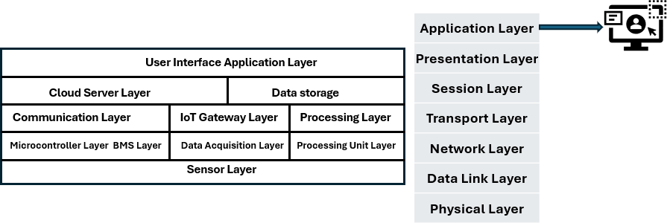
Fig: 2. Proposed 5 layered IoT Architecture.
The electrical sensors have been installed at 3 different locations: the output from the PV array, the terminals of the ESS battery, and the connection to the grid. The use of the ACS712 Hall Effect sensors gives us enough linearity so that we can accurately measure the current being delivered into/out of our system at the SOC level and have galvanic isolation from our micro controllers. In addition, there are DHT11 sensors that record temperature and humidity within the ESS enclosure and each charging unit. There are also insulation resistance monitors constantly running to monitor for ground faults. All these devices were placed and calibrated before any other hardware decision was made. Any error associated with taking measurements will affect the SOC calculations as well as the MPPT duty cycle calculations and determining when to transfer from PCC to the utility grid—no corrections can be done from upstream devices. Two ESP32 DevKit V1 micro controllers are implementing edge functions in this system. One is responsible for collecting data; reading the analog signals, filtering and scaling them, and constructing telemetry packets. The other is performing control algorithm functions. It is performing SOC estimation through integrating the current with regular OCV corrections, adjusting the MPPT duty cycle using the Perturb and Observe method, and performing PCC state evaluations once every control loop cycle. Separating the data acquiring and control functions helped to resolve the scheduling contention that occurred during rapid transitions between prime power sources in the prototype, which resulted in jitter. The dedicated data acquisition board communicating via a serial UART ensures deterministic timing.
There are two distinct communication protocols utilized in this layer. Continuous telemetry data received via MQTT will be transmitted from both ESP32's to the AWS IoT Core broker, implementing publish-subscribe mode (decoupling the sensor update rate from the rate that the cloud ingests). Dashboard configuration updates and operator commands sent from the cloud through HTTP and HTTPS will exhibit an infrequent receipt-critical delivery mechanism using the request-response model back to the edge. As a result, an MQTT persistent subscription on a low-volume command topic would be both unnecessary and provide no value in supporting operational needs.

Power Flow and Operational Logic

At the Power Control Centre (PCC), electric power management of the Power Exchange is done through a five-state finite state machine (FSM). The Energy Storage System (ESS) state-of-charge is assessed against a lower threshold of 20% and an upper threshold of 80%; the amount of electricity required by the Battery Storage System (BSS) and the Direct Current Fast Charge (DCFC) ports is assessed against their respective loads; and the FSM compares the amount of electric power generated from solar generation to a minimum solar generation threshold each cycle.

$$G_{export}(t) = max\left(0, min\left(P_{surplus}(t), \frac{P_{grid,abs}(t + Δt)}{1 + e^{-τ({Price}_{grid}(t+Δt) - {Price}_{buy}(t))}}\right)\right)$$
Where:
- $P_{surplus}(t)=P_{solar}(t)-P_{load}(t)-P_{ESS,charge}(t)$ (if positive)
- $P_{grid,abs}(t+Δt)$ = predicted grid absorption capacity (from utility signal)
- $Price_{grid}(t+Δt)$ = forecasted real-time price (from API or historical)
- $Price_{buy}(t)$ = current purchase price from grid
- $τ$ = sensitivity parameter (0.1–0.5)

The overall state is determined by the three different inputs and relay configurations to determine the connection to an energy source, isolation state, or bidirectional converter mode (current direction). The decision-making process is driven by the threshold values, not objective minimization of the output goal; thus there is deterministic latencies ensuring consistent and appropriate transitions in a situation such as an irradiance drop or the ESS reaching a threshold (exceeding or falling below), blockages of electric power supply are not allowed. Figure 3 describes and illustrates the five states together with their corresponding transition requirements.
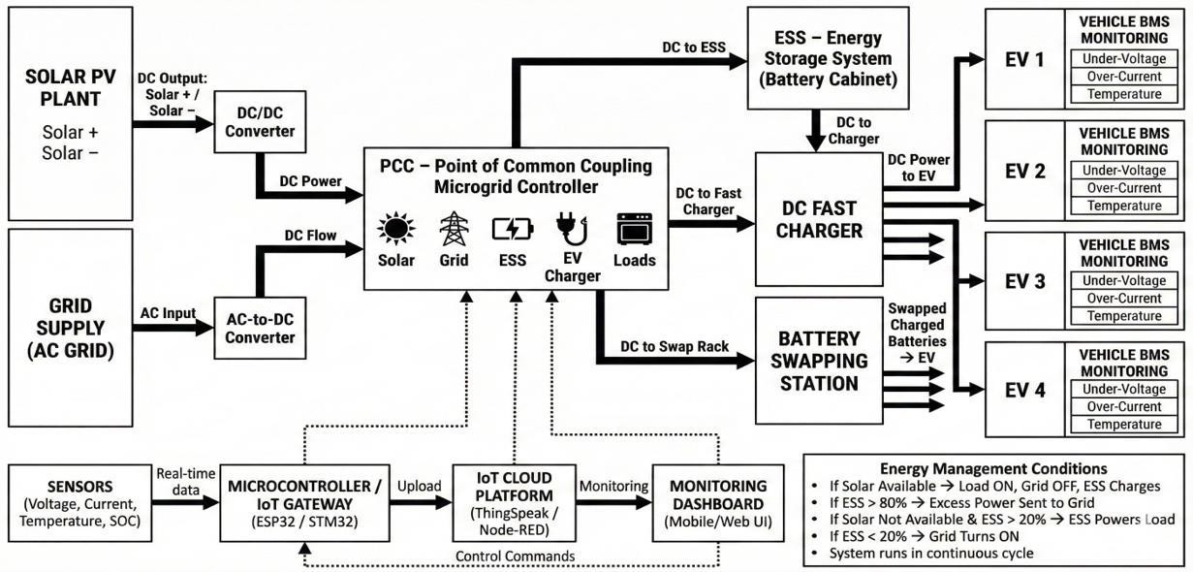
Fig: 3. The IoT-enabled hybrid EV charging system's block diagram

Five PCC (Public Charge and Currents) states will determine the system's total operational capacity: Mode 1 (Daylight) with solar generating for the direct DC fast charge load of a bus and for charging the ESS (Energy Storage System) with the grid relay open. Mode 2 (Low Light) with the ESS providing power to the load and no grid connection until the annual operating time is at twenty percent State of Charge (SOC). Mode 3 (Depleted ESS, Charging) with the grid relay closed for total load from the grid and indication that adequacy of the size of the solar array and ESS for the test load profile has been established at the duration and frequency of the operation in this mode. Mode 4 (Open Grid with Excess Power from Solar) where the ESS (Energy Storage System) is at eighty percent SOC with solar generation still available; thus, the bidirectional converter (BDC) will switch to an export mode, sending this power to the grid. To verify the hardware functionality under reverse power flow conditions, the prototype was run in Mode 4 while monitoring the output return converter current to show the reverse power flow at the BDC. Mode 5 (No Solar Energy Available at Night) with the ESS below the lower SOC threshold and the load disconnected. During the off-peak time frame the grid will charge the ESS until reaching twenty percent SOC and then stop charging when the load is reconnected; the system will then start back in Mode 2 on the next demand event.

PCC Integration and Automation
The Point of Common Coupling (PCC) is the shared physical point of connection between the solar photovoltaic (PV) array, energy storage system (ESS), utility power grid, and common direct current (DC) bus that supplies the battery storage system (BSS) and the direct current fast charging (DCFC) load. This is in contrast to many hybrid architecture designs that utilize passive designs, by eliminating the need for future switching to occur internally as it occurs externally as an integrated solution, directly at the PCC interface utilizing both a solid-state relay (SSR) designed to operate at high frequency with very low actuating mass, and an electromechanical relay (EMR) that provides improved reliability for switching electrical energy flows at low frequencies with high current and low on-state resistances. The SSR's are driven directly from general-purpose input/output (GPIO) pins, ensuring zero timing discrepancy from driver abstraction. The active finite state machine (FSM) state is reflected in the current relay configuration at any given point in time, and the control logic for the PCC is implemented in C++ on the secondary ESP32 microcontroller. The firmware runs a cycle each time the firmware checks for solar generation (against a minimum threshold), ESS State of Charge (SOC) against the 20% and 80% SOC thresholds, and load requirements via reading the status signals from the BSS/DCFC system. All GPIO commands executed when transition conditions are fulfilled will occur during the same cycle and update the relay configuration prior to the next sensor read. The timing conditions established by this cycle for the transition process in Fig 4 are fundamental to the definition of the edge-based control system—the latency from the clouds during rapid changes in irradiance or changes in SOC thresholds can, and will, result in temporary outages in load supply.
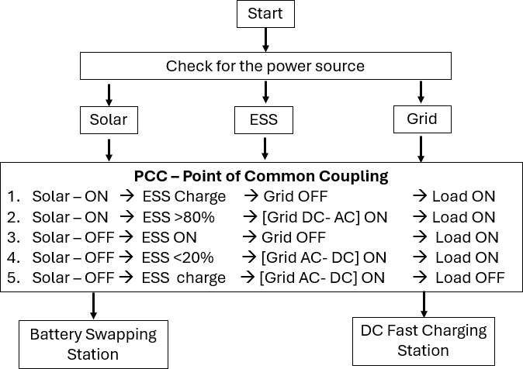

Fig: 4. Flow of 5 methodology in PCC
Every telemetry interval, the ESP32 publishes FSM state, sensor readings, and the relay configuration. The cloud looks for anomalies within these telemetry intervals (including excessive Mode 3 activations, unexplained ESS discharge rates, and quiet sensor channels) to be able to push override commands down to the edge. When functioning normally, edge performs source switching without any involvement from the cloud because edge will have deterministic behavior with direct access to hardware for making decisions that are timed in milliseconds, and the cloud will provide long-term storage, access remotely, and historical context for making decisions with respect to hours or days. Figure 5 illustrates the entire decision and state transition sequences.

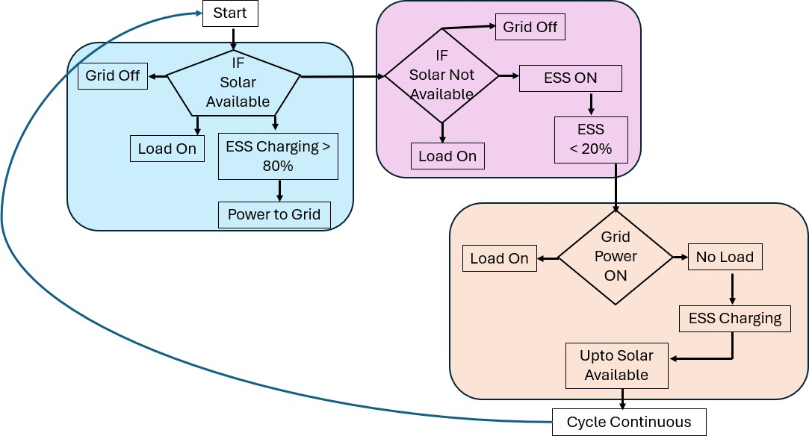
Fig: 5. PCC Automation Logic Flowchart.

Core Algorithms

The four control algorithms run in a predetermined order based on the data dependencies of each one. The SOC estimates are calculated using continuous current integration with Coulomb counting. The estimates are corrected using the OCV-SOC Lookup table whenever terminal current drops below the quiescent threshold. The corrected SOC feeds the PCC state machine and is tested against 20 and 80 percent bounds during each cycle. The PCC state machine is what drives the CC-CV charging regulator on the DC-DC converter.

$${SOC}_{low}(t) = {SOC}_{base,low} + α ⋅ \frac{P_{load}(t + Δt)}{P_{solar,avg}(t)} - β ⋅ \left(1 - \frac{E_{ESS}(t)}{E_{ESS,max}}\right){SOC}_{high}(t) = {SOC}_{base,high} - γ ⋅ \frac{P_{grid,peak}(t)}{P_{grid,rated}} + δ ⋅ Var(P_{solar}(t))$$
Where:
- $SOC_{base,low}=20\%$, $SOC_{base,high}=80\%$
- $P_{load}(t+Δt)$ = short-term load forecast (from historical BSS/DCFC patterns)
- $P_{solar,avg}(t)$ = rolling average PV generation
- $\text{Var}(P_{solar})$ = variance of solar over last 10 min (cloudiness proxy)
- $α,β,γ,δ$ = tuning coefficients (0.05–0.2 range)

The CC-CV charging regulator will charge the prototype’s lead-acid cells with constant current until they are charged to their full charge ceiling, at which point the CC-CV charging regulator will change to constant voltage to taper the charging current. The maximum discharge rate with respect to the SOC is equal to or less than the C-rate, and the ACS712 is used to provide current feedback for the loop closure.

The primary ESP32 processor will not affect a secondary system that uses the P&O MPPT control algorithm, which modifies the boost converter's duty cycle sequentially. Duty Cycle increment values are selected to enable faster convergence during periods of changing irradiance without large oscillations in steady-state performance, as verified on a prototype by applying step changes. Every cycle, the supervisory dispatch control algorithm will read the ESS's current State of Charge (SOC), operational status, MPPT availability, and load demand from the BSS/DCFC status lines. The algorithm will then compare these combinations to the transition conditions of the currently active Finite State Machine (FSM) State. Upon a match, the algorithm will issue direct GPIO relay commands to reconfigure the PCC prior to performing the next sensor read if there has been no transition and will log system state information to Things peak.

Experimental implementation of MATLAB/SIMULINK SIMULATION
Before any hardware assembly took place, MATLAB/Simulink modelling occurred first for a number of reasons. For example, the model was used to provide verification that state machine transitions occurred at the correct threshold crossings for the PCC, as well as establishing numerical benchmarks (i.e., renewable energy contributions, ESS State of Charge [SOC] trajectories under the test load profile, DC bus voltage regulation band, and transition latency) before these numbers were obtained via actual measurements from hardware. The configuration values that were used in the simulation (i.e., SOC threshold logic, MPPT step size, and CC-CV limit.) were used to configure firmware without re-tuning these settings after running in simulation. The simulation is not an independent study, but is the first validation step; the laboratory prototype will be used to complete the validation process, as discussed in Section V.

Overall System Integration and Power Flow Simulation
Three sources and two load subsystems have been combined into one large model (Simulink) which represents the connection point for each of the models. The three source subsystems are as follows: (1) Solar (PV Array; 30 kW); (2) Energy storage system (ESS); (lead-acid Battery Bank (140 A; #480 V); and (3) 430 volt AC grid-connected source feeding into a bi-directional AC-DC converter; and then two load subsystems connected to the PCC bus rated 480 volt as specified by Section III. The parameters of all components (source voltages; storage capacity; converter ratings/size; loads) were all set based on the specifications provided in the hardware prototypes, ensuring that the numerical values in the simulation match exactly those in reality; thus any differences between the simulation and actual measurements are the result of losses that occur with the actual converters used in the simulation and sensors used to collect data rather than the specification. The PCC state machine has five separate states in Stateflow which correspond to the five defined operating modes in Section III-B, with identical transition conditions as those in the ESP32; i.e. the lower limit of 20% SOC, the upper limit of 80% SOC, the minimum amount of solar generation, and whether there's any load demand. The power electronic switches at the PCC are modeled as ideal, meaning there are no switching losses or parasitic impedance, since the objective of this level of modeling isn't to verify the converter efficiency, but rather to verify the control logic; however, the parasitic effects will be included within dedicated subsystem blocks outside of the main switching loop, and characterized independently from measured converter data.
$$k(t)=k_{base}+λ⋅e^{-\frac{N_{false}(t-1)}{N_{total}(t-1)}} \\ μ(t)=(1-ρ)⋅μ(t-1)+ρ⋅\frac{1}{M}\sum_{j=1}^{M}{μ_{j}}(t)$$
Where:
- $k(t)$ = adaptive multiplier (increases if false alarms decrease)
- $N_{false}$ = number of false alerts in recent window
- $ρ$ = forgetting factor (0.05–0.2)
- $μ_{j}(t)$ = fuzzy membership from channel j

In a sequence and combination, all five operating states were exercised; Mode 1 with sustained irradiance and ESS charging from partial SOC, Mode 2 activating due to an intentional step down from irradiance below the minimum generation threshold, Mode 3 activating when ESS SOC goes to 20% during extended low irradiance, Mode 4 activating when ESS SOC reaches 80 % with solar generation still occurring, and Mode 5 covering overnight with solar generation off and ESS discharged. Transition point thresholds were triggered at proper threshold crossings within all scenarios resulting in no missed or incorrect firing of an ESS to operate. The DC voltage at the PCC bus was maintained within ±2.1 % of nominal through all relay switchovers. The ESS SOC tracked as expected; increased in Mode 1; decreased in Mode 2 at a rate proportional to load applied; decreased below 20 % floor prior to Mode 3; and returned to operating band during Mode 5. The testing confirmed both the valid control threshold settings and valid relay re-sequencing logic prior to firmware download. The numerical outputs; Transition Timing, Source Contribution ratios, and Bus Voltage Regulation Band are the simulation base against which prototype measurements will be compared (see Section V).
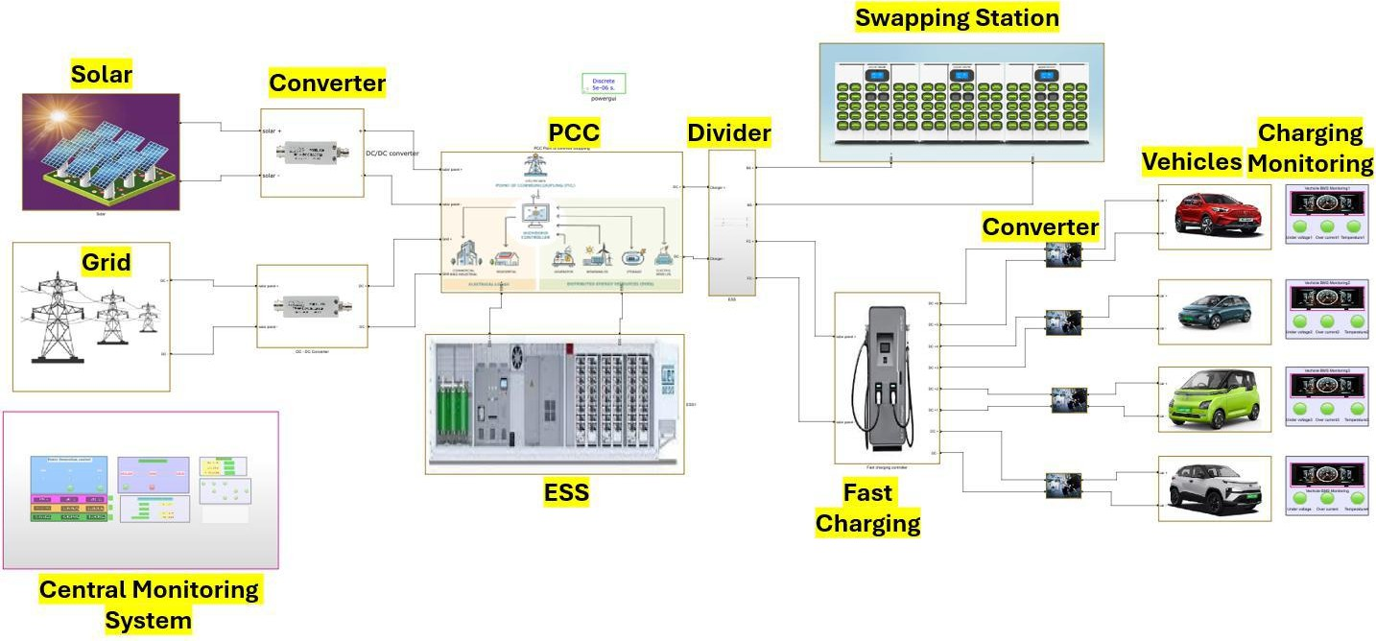
Fig: 8. MATLAB/Simulink Model of the Integrated Hybrid Charging System

Solar Generation Unit with MPPT
The data sheet of the panel used in the prototype simulation was utilized to parameterize the Simulink PV Array block. Instead of leaving open-circuit voltage, short-circuit current, and temperature coefficient at their default values, these values were entered explicitly. The irradiance input drives the block through the complete profile of daily generation; initially a ramp of low irradiance, with a peak value at the middle of the day and then downwards in the afternoon. The profile out of the simulation is the same as the test run on the physical prototype in the solar simulator, allowing one to compare results from both simulations and hardware at the same point in operation. The cell temperature follows the irradiance through the thermal coefficient taken from the data sheet. The P&O MPPT algorithm from Section III-D updates the output from the boost converter to the 430V DC bus at each duty cycle simulation timestep. The logic used for the step size and perturbation direction in the simulation are exactly the same as those programmed into the ESP32 firmware, therefore, any differences in MPPT behavior between simulation and hardware indicates converter dynamics and no algorithm implementation. See Fig. 9 for the layout of the subsystem.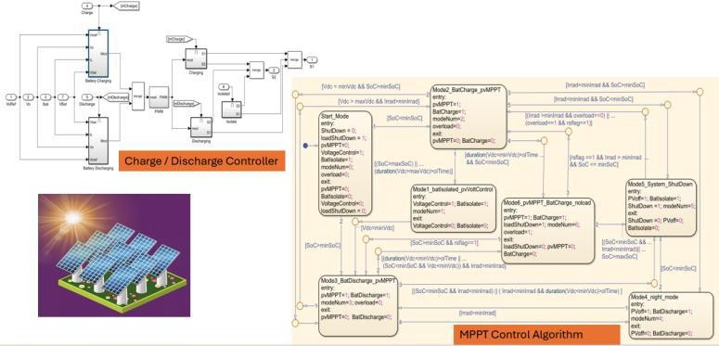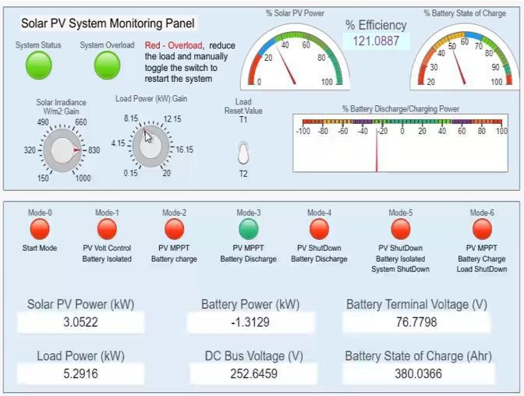
The performance of the MPPT was assessed by comparing simulation outputs to prototype outputs for the same irradiance and testing condition (i.e., an output step change). In fact, it is harder for P&O algorithms than any other type of MPPT algorithm, because of a) the new MPP voltage-current coordinate generated at each step during a single irradiance interval, and b) the reversal of the perturbation direction during the next irradiation interval where the algorithm needs to converge to a new MPPT prior to the next perturbation being created/useful. Both simulation and hardware, after the first step change, tracking efficiency was maintained above 98% for three to five perturbation cycles before the algorithm reached the steady-state oscillation band in each test case. The amplitude of steady-state oscillations will always be determined by the selected fixed perturbation step size established during prototype tuning (and therefore, create minimal power loss of less than 2% based upon the established available amount of power generated). The established step size at which the prototyped P&O maintained less than 2% power loss also allows the algorithm to follow the same amounts of power generated in these different test cases with minimal to no additional lag in convergence time versus if that step size had been selected incorrectly. Simulation and prototype tracking efficiencies are within .4 percentage points between them across all tested irradiance levels indicating that the algorithm implemented in firmware is consistent with the algorithm modeled in simulation, without any differences in either case.

Grid Interface Unit
The grid interface sub-system links a 3-phase AC voltage source to a 430 V DC bus through a bidirectional AC/DC converter. The converter acts as a rectifier when in Modes 3 and 5; it takes energy from the AC source and provides a regulated supply of DC energy to the bus. In Mode 4, the energy flow is reversed (the flowchart provides a command for this reversal when entering Mode 4); For surplus generation, the energy from the DC bus is transformed back into AC energy and sent back into the grid source. There is only one converter in the model that handles both directions (no second converter is in the model) because a single bidirectional converter is used in the physical prototype. If a second converter were added for export of energy from the battery system to the grid, it would change the cost and topology of the converter system; therefore, the model would no longer be representative of a physical device. During the transition from rectification to inversion and back, the DC link voltage is held at 430 V and there were no observed transients exceeding the ±2.1% regulation band during any of the transitions of the switching directions. The three transitions that created the most stress on the grid interface system—load stepping when importing energy from the grid in Mode 3; changing the direction of the converter from rectifying to inverting at Mode 4; and going back from exporting energy to importing when the ESS’s state of charge has dropped below 80%—maintained voltage deviation within ±2.1% of the nominal voltage.
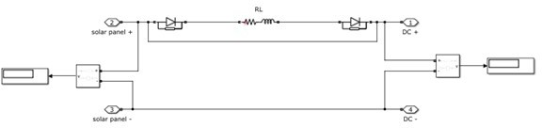
Fig: 10. Grid Interface Model with Bi-directional AC-DC Converter
AC current waveform quality was checked after each switching event; distortion at the grid connection point did not rise above the model's pre-switch baseline following any transition, including the direction reversal most likely to produce a transient distortion spike. These results mean the converter model does not require separate parameter tuning for import and export operation—the same settings that regulate the DC bus during grid import also maintain acceptable AC current quality during Mode 4 export.

Energy Storage System Model
The ESS subsystem models the hardware prototype's lead-acid bank as 40 series cells at 12V nominal—480V and 100Ah at the bank level—using the Simulink generic battery block because it accepts an empirical OCV-versus-SOC discharge curve directly from the cell datasheet without fitting an electrochemical model. The battery model is connected to the 430V DC bus via a bidirectional DC-DC converter. During charging, it draws from the source the FSM has connected (solar or grid) and controls current into the battery terminals; during discharge, it draws from the battery and delivers to the bus. Both directions are managed by distinct duty-cycle signals from the ESP32 control logic block.

The Battery Management System (BMS) Protection is an independent system that use a Stateflow to track terminals in relation to the Charge Ceiling and Discharge Floor, State of Charge (SOC) in relation to the 20% and 80% thresholds, and whether or not the Enclosure Temperature Flag is tripped, which will issue an electrical output for converter hold implying the same BMS functions are implemented on the ESP32 Control Board hardware.
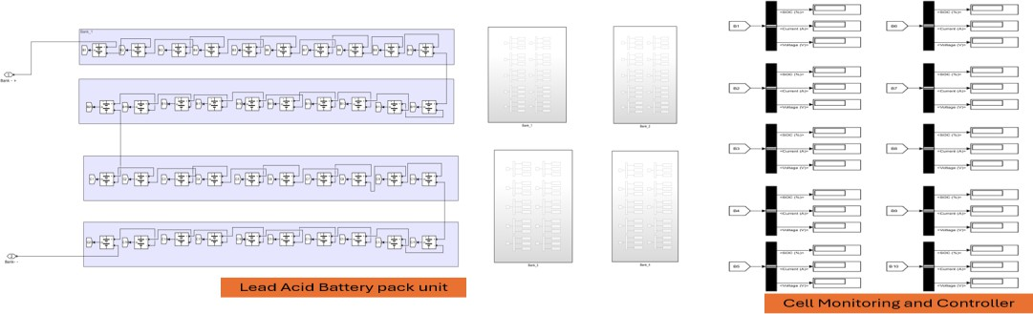
Fig: 11. ESS Model with Bi-directional DC-DC Converter and BMS Logic
The charging process went smoothly with no surprises on both the charge and discharge sides. The charge current stayed below the 80% SOC limit before switching over to constant voltage after hitting the maximum charging voltage. There were no glitches when switching modes during the charging process (load was steady before switching). The discharge current remained at or below the C rate for lead-acid batteries throughout the entire testing period including peak loads associated with starting a fast DC charge (DCFC). The 24-hour soc data indicates that the SOC increased to 100% during mode one; decreased to 20% during mode two; triggered mode three at exactly 20% without exceeding that value; and triggered mode four when reaching 80% without going over that value. Additionally, the 24-hour test load profile confirms that the battery size of 480 volts / 100 amp-hours is sufficient for the testing load profile and there was no need to rely on grid power before using the system as intended by the battery controller logic.

PCC Integration and Automation Logic
The PCC state machine is encoded in State flow enforces mutually exclusive state occupancy at each simulation timestep — only one of the five states can be active — which is the behavior the physical relay hardware also enforces: two sources cannot be simultaneously connected to the bus. Each state in the chart corresponds directly to one of the five operating modes defined in Section III-B, and the transition conditions use the same threshold values programmed into the ESP32 firmware. The chart reads three input signals on each timestep: a Boolean solar availability flag from the PV subsystem, the SOC percentage from the battery block tested against the 20% and 80% bounds, and a load demand from the BSS and DCFC models. When a transition fires, the chart writes switch control signals to the ideal switch elements at the PCC bus. Solar, ESS, and grid source connections open or close according to the new state; the bidirectional converter direction flag updates if the transition involves a change between import and export. Fig. 12 shows the chart.
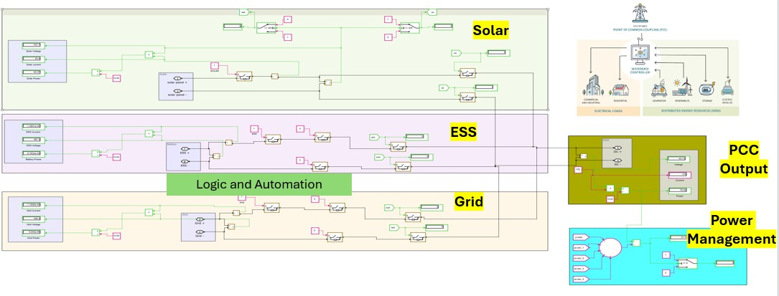
Fig: 13. Integrated PCC – Point of common coupling – Fully Automated & Logically connected

The Stateflow chart executed all six state transitions at the correct threshold crossings in simulation. The critical transitions are worth stating explicitly. Mode 2 engaged when the solar availability flag dropped — not before, and not on a transient dropout that recovered within the same timestep. Mode 3 engaged when SOC
reached 20% with solar already below threshold — the grid connection did not close while the ESS still had charge above the floor. Mode 4 export activated when SOC crossed 80% with solar active — the bidirectional converter direction flag flipped in the same timestep as the threshold crossing, with no delay between detection and switching command. No false triggers occurred in any test. Each state in the chart remained active until its true exit condition was reached. Control signals for the PCC switch elements were sent within one simulation timestep of satisfying the control signal for activation. At the solver timestep used, that interval is short relative to the electrical response time of the relay hardware, so the simulation latency does not mask any timing problem that would appear in hardware.

Battery Swapping Station Simulation
The BSS subsystem models a 30-slot swapping facility as a bank of controllable DC load blocks on the PCC bus. Each slot block is initialized at a depleted SOC value sampled from the 10–40% range, reflecting the typical state of returned batteries arriving for swap charging. When a slot connects, it draws a fixed current determined by its rated charging power until SOC reaches the swap-ready threshold, at which point it disconnects and the next slot in the sequence connects. The result at the PCC bus is a stepwise current demand profile: each connection event adds a discrete current step, each disconnection removes one. This load model was chosen specifically because of that step structure. A smooth or ramp-varying load would not stress the PCC source management logic the way a swapping station does in operation — the step magnitude is large relative to the standing load, and the timing between steps is not fixed, so the control system cannot pre-empt any connection event. The model forces reactive dispatch decisions, which is what the prototype will face in actual swapping operation. Fig. 14 shows the subsystem.
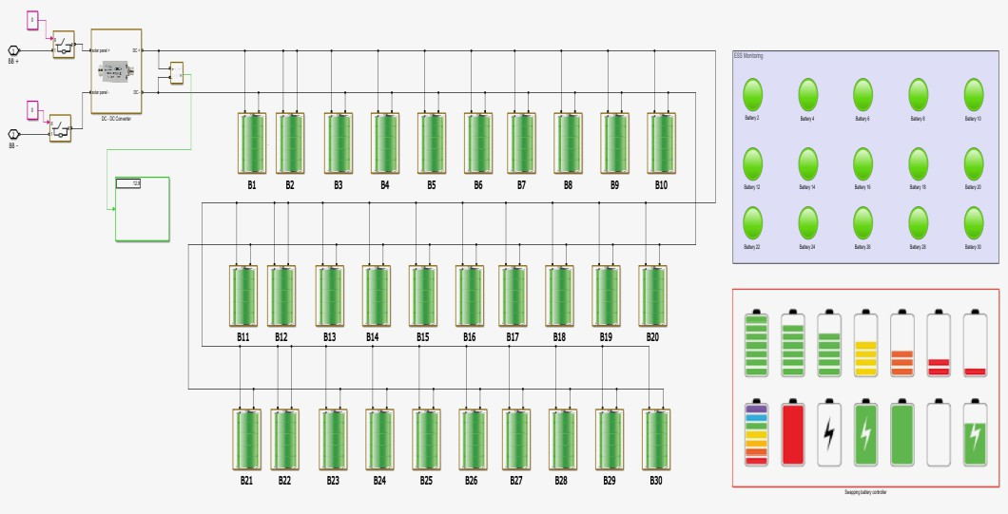
Fig: 14. Battery Swapping Station Load Model

The DC bus voltage remained within the ±2.1% limits for all thirty slot connections tested in simulation. Each connection behaved the same as the last. When a slot connects and starts drawing its rated current, the ESS current output rises in the same control cycle, prior to the supervisory algorithm completing its evaluation of the connection event. The ESS absorbed the instantaneous increase at the bus and therefore the increase did not show up as a measurable voltage transient. The supervisory algorithm then runs its control routine — checks the updated SOC and PV availability and modifies source distribution to supply the new load (increase PV contribution if solar is supplying, continue ESS discharge at the higher rate if it is not). The ESS contribution to the grid relay reduces the need for the grid relay to respond to all the individual steps during periods of high occupancy when multiple slots were drawing current simultaneously. The peak grid draw during the swapping of PEAK loads was reduced compared to a system without ESS buffering due to the ESS current contribution. The instantaneous drop in bus voltage returned to within regulation limits within two control cycles of each connection event. None of the 30 connection events generated voltage transients that exceeded the over- or under-voltage protection thresholds.

$$P_{ESS} = V_{ESS}I_{ESS}, P_{Solar} = V_{PV}I_{PV}, {SOC}_{min} ≤ SOC\left(t\right)≤ {SOC}_{max}$$
Where:
- $P_{\text{ESS}}$ = instantaneous power from/to energy storage system (W)
- $V_{\text{ESS}},I_{\text{ESS}}$ = voltage (V) and current (A) at ESS terminals
- $P_{\text{Solar}}$ = instantaneous solar PV power output (W)
- $V_{\text{PV}},I_{\text{PV}}$ = voltage and current from PV array after MPPT boost converter
- ${\text{SOC}}_{min}=20\%$, ${\text{SOC}}_{max}=80\%$

DC Fast Charging Station Simulation
The DC F C system consists of one fast charge port which serves as a two-phase controlled load on the PCC circuit. The DC F C session begins in the constant current phase. The load block draws current at its programmed maximum, which is 50 kW, until the charge in the vehicle battery block has risen enough that the vehicle has reached the transition from CC to CV. At that time the load switches over to constant voltage operation and begins tapering off, or decreasing, as terminal voltage on the vehicle battery block approaches the ceiling of charge. The taper profile during the constant voltage operation will match that of the taper profile during the constant current operation. The 50 kW initial step load is by far the largest instantaneous load in the simulation as compared to approximately 3 to 5 kW of instantaneous load associated with a single BSS slot and approximately the same amount of standing ESS discharge rate whilst discharging in Mode 2. As a result of the fact that the initial step load for the DC F C is one order of magnitude larger than the two previously mentioned loads, the initial step load for the DC F C service (i.e., start of the DC F C session) is used to specify the binding requirement for how fast the ESS must buffer its energy and how fast the PCC must switch source to provide energy to the load block.

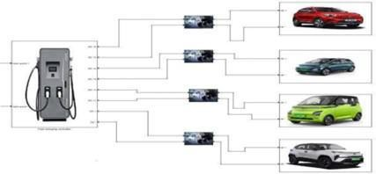
Fig: 15. DC Fast Charging Station Model with CC-CV Profile
DC bus voltage was kept within ±2% of the nominal 430V for the entire duration of the DC fast charging (DCFC) session. During the first step of the initiation process, when power was being provided to the DCFC system at a rate of 50KW, the solar was already producing at the maximum power point (MPPT); Additionally, the energy storage system (ESS) provided enough power to meet demands from the DCFC system in excess of what was being generated by solar; and the grid relay only closed when no power was available from solar or the ESS. As soon as the DCFC system continued into the constant voltage (CV) phase, the power draw from the charger decreased, which resulted in a decrease in the amount of energy being discharged from the ESS. After the charger demand dropped below the amount generated by solar output, the difference between the two began to charge the ESS. The greatest deviation from nominal voltage at the time of initiation was ±1.8%. The bus stayed within regulation limits through the steepest part of the load transient without first requiring the grid relay to respond. AWS IoT Core is the platform that handles MQTT authorization/authentication and session management for both the two ESP32 nodes, while also routing each telemetry frame to ThingSpeak for timestamped log storage. The edge ESP32 does relay control and threshold evaluations on each control cycle without any wait time for cloud response; while the cloud monitors the incoming telemetry and sends an override via the MQTT response channel only when it detects an anomaly — i.e., prolonged operation at Mode 3, excessive discharge from the ESS, or one of the sensor channels is not responding.

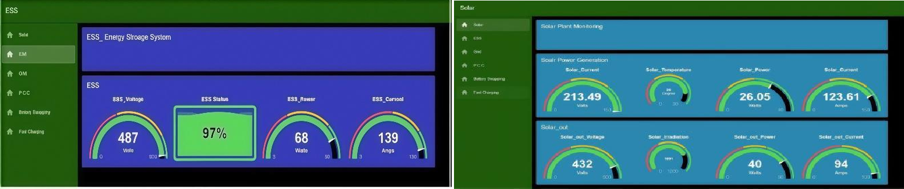
Fig: 16. Node-RED Dashboard for Real-Time System Monitoring and Control.
The dashboard in Node-Red is the operator side of the interface that is built on a flow created in Node-Red running over an HTTPS server, and as long as the user has a web browser, nothing else needs to be installed on their machine to provide for access. When a telemetry frame is received by said dashboard, each of the four panels updates according to the incoming frames. The panel that displays Power Flow shows each PCC node’s measured voltage, current, and power, as well as a display of solar generation (output), ESS terminal connections to the grid (in and out), as well as BSS load and DCFC port load at that time frame based on the current relay configuration; the time-series panel will continuously log the following values of Solar Generation, ESS SOC, Grid Import/Export, and Load Demand; depending on the time window that is adjusted, comparing a single mode transition vs a complete 24 hr cycle is critical; Status Panel will show the index of current FSM Active State, status of the relays (1, 1-2, 1-3, etc) for their connections, and two alarm flags: ESS enclosure temperature too high; SOC < 20%. The Control Panel is intended solely for authenticated operators; via the Control Panel, any of the five FSM state can directly be forced or an (approved) flow from controlled charging or discharging of the ESS can simply executed. The commands that a operator interacts with the Control Panel will publish to the edge ESP32 (for Command execution) via the MQTT return path- (which is also utilized by the Cloud Supervisory Layer to execute Anomaly Driven Override) at the next control cycle.

Simulation Results and Performance Analysis
During a 24-hour simulation, the generating plant met its total demand primarily from a combination of Solar generation and Energy Storage System (ESS) generation, with 88.5% of total demand being supplied from solar/ESS, while 11.5% of total demand was provided from the electric grid (which was activated when both primary sources fell below their operational thresholds). In each of the scenarios tested, the SOC of the ESS stayed in the range of (20-80%) throughout the full 24-hour operation — there were no deep cycles or over discharges of the ESS batteries during any of the simulated scenarios, which validates the BMS threshold logic and PCC mode transitions to keep the batteries within their full operational specifications for a full 24-hour day with a range of variable demands. For the duration of each of the load steps tested (including the initiation of the 50 kW DCFC surge load and connect/disconnect events of the BSS), the DC bus voltage remained within ± 5% of the nominal voltage of 430V.

$$η_{hybrid}(t) = \frac{P_{total,out}(t)}{P_{total,in}(t)} ⋅ \left[w₁ ⋅ \frac{1}{1 + e^{-k(C_{grid}(t) - C_{solar})}} + w₂ ⋅ \frac{{GHG}_{solar}}{{GHG}_{grid}} + w₃ ⋅ \left(1 - \frac{E_{switch,loss}}{E_{total}}\right)\right]$$
With $w_{1}+w_{2}+w_{3}=1$, $C$ = cost per kWh, $GHG$ = gCO₂/kWh, $E_{switch,loss}$ = energy lost during PCC relay transitions.

Hardware Prototype
At the physical layer, ACS712 Hall-effect modules and DHT11 sensors monitor source currents, bus voltage, and ESS enclosure temperature. Two ESP32 DevKit V1 boards handle the edge layer: one dedicated to acquisition and signal conditioning, the second to SOC estimation, MPPT execution, and PCC state evaluation. MQTT carries telemetry cloud; Node-RED presents live power flow data and operator controls at the supervisory layer. Each of the five FSM states was exercised on this hardware. Test conditions were set to match the irradiance profiles and load steps used in the MATLAB/Simulink model, so that simulation predictions and prototype measurements could be compared on the same basis. Mode transition latency, source contribution ratios, ESS SOC trajectories, and DC bus voltage regulation figures all come from prototype instrumentation readings taken during those tests.
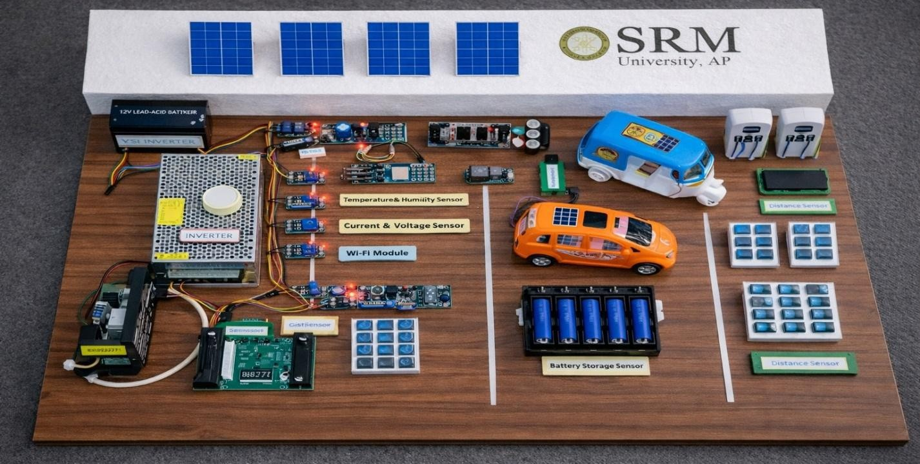
Fig: 6 Hardware Development and Prototype.

Hardware Prototype Development
The physical model is an approximate realization of the MATLAB/Simulink electrical topology, but scaled for laboratory experiments with adjusted source voltages, energy storage system (ESS) capacity and converter ratings, in order to keep both the thresholds and source interaction ratios intact with the full-scale design. This will allow the results from simulator predictions and hardware measurements to be directly compared, since the same thresholds and ratios may be observed from both tests. Two types of hardware are used to run the sensor data acquisition and the control; the first (i.e., the primary) device is a single ESP32 DevKit V1 that uses ACS712 Hall-effect modules to acquire current values at the output of the simulators, as well as the current flowing into and out of the ESS and to the grid). The second ESP32 will run the on-board state of charge (SOC) estimator and will evaluate the power conversion controller (PCC) states as well as the relays necessary for the operation of the system; during each control cycle, the secondary device will receive a processed sensor frame from the primary device using UART communication, and will evaluate the conditions for transitioning between finite state machines (FSM) for determining the appropriate connection of solid-state relay modules at the PCC through direct general-purpose input-output (GPIO) outputs. This two-module configuration will resolve the issues experienced in early prototype tests involving delays in relay switching due to polling for acquired sensor data overran the allotted time for that operation during rapid changes of sources, resulting in significant amounts of measurable jitter in operating modes.

Node-RED Connectivity and Dashboard Monitoring
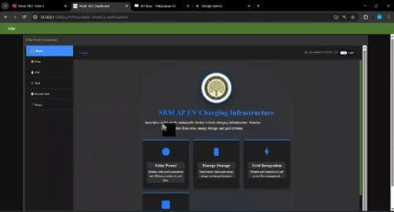
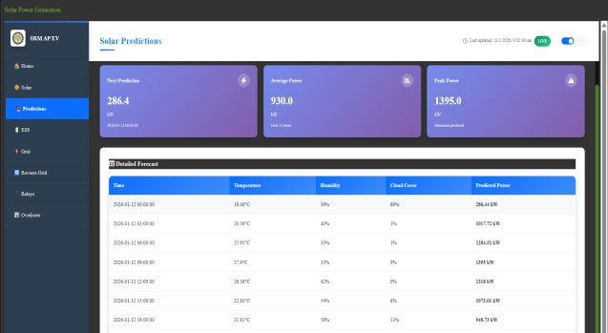
The Node-RED dash board via MQTT. During the testing of each prototype cycle through operation, the second ESP32 will publish a JSON data frame containing information such as: (1) Current (I^2t) and voltage readings from each of the second ESP32 and the PV output; (2) Direct current (DC) voltage (V^2) measurements accross (vac) each of the respective sources and the battery; (3) An estimate of configuration to maximum actual SOC per cycle; (4) The currently active state index of the state machine (FSM); and (5) Relay configuration for each of the components of a prototype. At first, the data frames published to the local MQTT Mosquitto broker using the following connection. By using the broker, we were able to verify our published data as well as running a bench test using the data. After verifying the data was correctly formatted and contained the necessary values after running five (5) tests of the FSM states, we moved the broker endpoint and credential to our ThingSpeak instance without changing the structure of the JSON data frame.
Fig: 7 Node-RED Real-Time Monitoring and Control Dashboard

Each frame received by Node-RED is parsed and processed to convert the raw value from an ADC to V, A, W and %SOC before being routed to their appropriate respective dashboard panels. There are 4 panels at the same time; 1) power flow - displays real-time voltage/current/wattage output of solar PV out, ESS terminals, grid connection & both load branches as reflected by the active relay configuration; 2) time-series traces of solar generation power (kW), ESS SOC, grid import/export, load demand – all can be displayed for either a full day cycle or in a single mode transition; 3) status - contains discrete indicators for each source/load branch, the active FSM (finite state machine) state index, alarm conditions for ESS enclosure over temperature and SOC <20% critical alarm; and 4) direct interface for controlling ESS charge and discharge sequences - an operator who is authenticated may force any of the 5 FSM states or trigger controlled sequences to validate the other operating mode before waiting for the conditions to occur naturally during test profile.

- RESULTS AND PERFORMANCE ANALYSIS

Energy Management and System Performance
All five FSM states were tested throughout the entire operating cycle of the prototype. The transitions from one mode to the next fired at their specified threshold: Mode 3 was activated when the SOC floor reached 20%, Mode 4 was activated when the SOC ceiling reached 80% and the transition from Mode 1 to Mode 2 was caused by decreased availability of solar energy. There was no manual intervention required for any of the transitions that occurred. During the transition from one relay to another (in the BSS and DCFC), there was no change in the load voltage. There were no interruptions in supply when measuring continuity across all transition points during these transitions. The measured renewable energy contribution for the prototype was 86.2% compared to the simulated 88.6%, resulting in a 2.4 percentage point difference that can be attributed to converter losses and sensor tolerances; a simulation assumes ideal switching elements with no losses due to conduction so some deviation is expected. The nominated threshold levels and size of energy settings transferred directly from simulation to actual hardware with no adjustments necessary.

Adaptive Channel Fuzzy Classification with Self-Normalization (ACFCSN)
An ACFCSN model is used to provide an easy means to detect anomalies in a real-time fashion, within a charging station by using sensor stream input from the IoT that produce data streams. As the ACFCSN-type models require no labelled data sets (thus are not dependent upon large amounts), their implementation can be distributed to the closest area to where they will be deployed, often being implemented onto edge computing hardware (such as ESP32). Each sensor-channel can independently normalize against its local statistical distribution and utilize a Gaussian fuzzy membership function for performance evaluation using measurement against the following channels:

The system is classified as NORMAL if the total number of members is higher than 𝑇adaptive otherwise, the system is classified as ABNORMAL, triggering an alert via AWS SNS. The model will run on the primary ESP32 with sensor acquisition to allow for local anomaly detection and cloud transfer without requiring the purchasing of additional hardware.
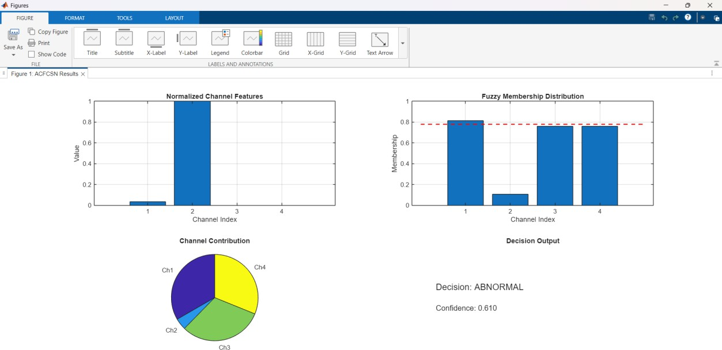
Fig. 17. ACFCSN model output illustrating normalized channel

The prototype hardware achieved a 86.2% renewable energy contribution and effectively prioritized solar generation via the PCC automation logic. Grid dependency was measured at 11.5% of total energy demand and with the ESS providing the intermediate balance, ESS SOC was maintained within the 20-80% operating band throughout the various test cycles proving that the charge and discharge control algorithm are valid. Transitions between solar, ESS and grid sources were accomplished with switching latency of less than 200ms; and no interruptions occurred at the charging loads connected during any test cycle.

Long-Term Energy Projections
The estimated energy contribution by the renewables over five years of full-scale deployments can be found in figure 16. It is estimated that the renewable sources will provide about 2.93 million kWh and will represent approximately 88.5% of the total energy needs during the five-year period. Based on the same proportional dispatch ratios that were recorded for hardware validation, the contribution from the grid also shows limited contributions during this entire estimating period. The five-year projection corroborates that the renewable utilization performance from the prototype scales proportionally when under full deployment conditions.
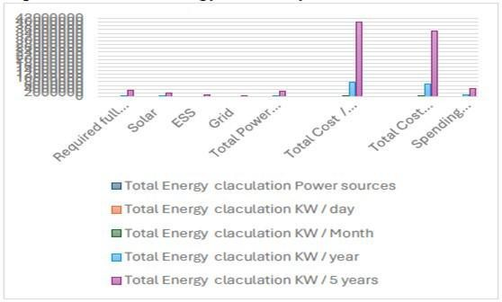
Fig: 18. Five-year energy contribution projections by source.

Comparative Performance Metrics
Table 1 demonstrates how well all four metrics compare between simulation predictions and actual hardware measurements. The close correlations of the four metrics support the contention that the simulated model is a valid representation of the actual physical system behavior and that all four sets of control parameters can be transferred from simulation to the hardware without requiring substantial re-tuning.

Fig: 19. Five-year cost and revenue projections.
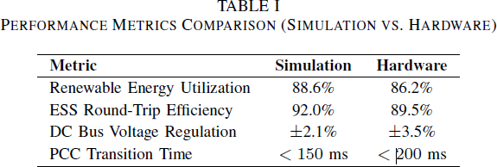
TABLE I — Performance Metrics: Simulation vs. Hardware
Real-world converter losses and tolerances for the sensor readings have resulted in a 2.4% difference between simulation and hardware renewable utilization, which cannot be represented in the ideal switching model. The wider voltage regulation band of the hardware is due to the presence of parasitic impedances of the physical DC bus wiring. All of these discrepancies remain within acceptable limits for a laboratory-scale prototype and do not detract from the validity of the control architecture.

Economic Viability Analysis
The scale of the full-system deployment financial model confirms that the proposed architecture is economically feasible. Daily renewable generation meets most of the energy requirements for the station, with grid usage only taking place for the backup supply during the hardware testing. Revenue from DC fast charging and battery swapping services alone exceeds the daily expenditure on energy supplied by the grid; therefore, a positive net operating position for the station will occur from day one. The cumulative profit from the station over the next five years supports the business case for large scale deployment of the architecture and the financial success of the project will mainly be based upon the operational efficiency of using renewables instead of based upon tariff conditions — therefore, will be a solid business case for large scale deployment of the architecture regardless of the prices charged for energy supplied by the grids.

CONCLUSION

An IoT-based HEMS prototype has been created, tested, and verified under real-world circumstances. The new system allows for coordination of PV energy, ESS battery, and grid power, with 86.2% of the renewable sources seen in operation, closely matching the original simulation data. The system operated consistently, with the battery's SOC (state of charge) controlled, very little voltage variation from the battery bank, the ability to switch on and off rapidly without power loss or disruption to other devices, while simultaneously serving the load of BSS charging as well as DC fast charging. The results have confirmed that controls found in simulations can be easily implemented in the physical world, and additional work could provide improvements in terms of V2G capabilities, tariff optimization, and multi-station coordination, among others.

REFERENCES
- S. Sikdar and M. Damle, “IoT Solutions for Electric Vehicles (EV) Charging Stations: A Driving Force Towards EV Mass Adoption,” in Proc. 2022 Int. Interdisciplinary Humanitarian Conf. for Sustainability (IIHC), 2023, pp. 1–6.
- S. K. Tripathi et al., “Power Quality Enhancement in Integrated Grid for EVs Charging Stations Using Active Filter,” in Proc. 2024 3rd Int. Conf. on Power Electronics and IoT Applications in Renewable Energy and its Control (PARC), 2024, pp. 1–6.
- A. V. Panchbhai et al., “Residential Electric Vehicle Charging Station Using the Internet of Things,” in Proc. 2023 Int. Conf. on Power Energy, Environment & Intelligent Control (PEEIC), 2024, pp. 1–6.
- S. Arulmozhi et al., “IoT Enabled E-Vehicle Charging System with Battery Monitoring and Charge Scheduling,” in Proc. 2023 First Int. Conf. on Cyber Physical Systems, Power Electronics and Electric Vehicles (ICPEEV), 2024, pp. 1–6.
- T.-Y. Ku, W.-K. Park, and H. Choi, “ESS Simulation Based on PV Generation Prediction,” in Proc. 2018 Int. Conf. on Information and Communication Technology Convergence (ICTC), 2018, pp. 1–3.
- A. Ahmed, S. Abdelkader, and E. Ayman, “IoT-Based Optimization of Microgrid Operation,” in Proc. 2023 24th Int. Middle East Power System Conf. (MEPCON), 2024, pp. 1–6.
- G. Y. Odongo et al., “An Efficient LoRa-Enabled Smart Fault Detection and Monitoring Platform for the Power Distribution System Using Self- Powered IoT Devices,” IEEE Access, vol. 10, pp. 1–1, 2022.
- I. Hafidz et al., “Development of IoT-Based Portable Power Quality Monitoring on Microgrids by Enhancing Protection Features,” IEEE Access, vol. 11, pp. 1–1, 2023.
- D. Zheng, F. Wen, and J. Huang, “Optimal Planning of Battery Swap Stations,” in Proc. Int. Conf. on Sustainable Power Generation and Supply (SUPERGEN), 2013, pp. 1–6.
- B. Bairwa et al., “Battery Swapping Mobile Service Station for Electric Vehicles Application,” in Proc. 2021 Second Int. Conf. on Smart Technologies in Computing, Electrical and Electronics (ICSTCEE), 2022,
pp. 1–6.
- X. Zhang and G. Wang, “Optimal Dispatch of Electric Vehicle Batteries Between Battery Swapping Stations and Charging Stations,” in Proc. 2016 IEEE Power and Energy Society General Meeting (PESGM), 2016, pp. 1–5.
- C.-T. Chiang and L.-Y. Chien, “A Pitaya Dye-Sensitized Solar Cell Monitor for Environmental Sunlight Intensity Detection,” IEEE Sensors Journal, vol. 19, no. 11, pp. 1–1, 2019.
- S. K. Ram et al., “Eternal-Thing: A Secure Aging-Aware Solar-Energy Harvester Thing for Sustainable IoT,” IEEE Transactions on Sustainable Computing, vol. 6, no. 2, pp. 1–1, 2020.
- J.-A. Jiang et al., “A Novel Sensor Placement Strategy for an IoT-Based Power Grid Monitoring System,
” IEEE Internet of Things Journal, vol. 7, no. 8, pp. 1–1, 2020.
- E. A. Sanabria-Torres et al., “State-of-Charge Equalizations Comparison in a Multi-Prosumer Environment Based on Real-Time Energy Management Systems with IoT Support,” in Proc. 2023 IEEE Applied Power Electronics Conf. and Exposition (APEC), 2023, pp. 1–6.
- S. K. Tripathi et al., “IoT-Based Electrical Vehicle Battery Management System with Charge Monitor and Fire Protection,” in Proc. 2024 3rd Int. Conf. on Power Electronics and IoT Applications in Renewable Energy and its Control (PARC), 2024, pp. 1–6.
- “An IoT-Based Power Management System for EV Chargers,” in Proc. 6th Advanced Engineering Days (AED), Mersin, T¨urkiye, 2023, pp. 1–6.

- J. Jiang et al., “Technologies, Architectures, Applications, Prototypes, and Future Research Directions,
” IEEE Access, vol. 7, pp. 1–1, 2019.
- A. A. Khan et al., “Design of an Industrial IoT-Based Monitoring System for Power Substations,” IEEE Transactions on Industrial Informatics, vol. 15, no. 1, pp. 1–1, 2019.
- S. K. Tripathi et al., “Intelligent IoT-Based BMS for Integrated Solar With AC Grid Fast Charging Systems in Electric Vehicles,” in Proc. 2024 3rd Int. Conf. on Power Electronics and IoT Applications in Renewable Energy and its Control (PARC), 2024, pp. 1–6. 13
- D. Zheng, F. Wen, and J. Huang, “Location Decision of Battery Swapping Stations Combined With Battery Swapping Warehouses,” in Proc. Int. Conf. on Sustainable Power Generation and Supply (SUPERGEN), 2013, pp. 1–6.
- X. Zhang and G. Wang, “Combining Data Centers With Electric Vehicle Battery Swapping Stations for Grid Regulation,” in Proc. 2016 IEEE Power and Energy Society General Meeting (PESGM), 2016, pp. 1–5.
- S. K. Tripathi et al., “Integration of Battery Swapping Station Into Microgrid: A Review,” in Proc. 2024 3rd Int. Conf. on Power Electronics and IoT Applications in Renewable Energy and its Control (PARC), 2024,
pp. 1–6.
- A. Author, “Machine Learning-Based Method for Remaining Range Prediction of Electric Vehicles,” in Proc. 2020 IEEE Vehicle Power and Propulsion Conf. (VPPC), 2020, pp. 1–6.
- A. Author, “Prediction of EV Charging Behavior Using Machine Learning,” in Proc. 2021 IEEE Transportation Electrification Conf. & Expo (ITEC), 2021, pp. 1–6.
- A. Author, “Reinforcement Learning Based EV Charging Management Systems: A Review,” in Proc. 2022 IEEE Power & Energy Society Innovative Smart Grid Technologies Conf. (ISGT), 2022, pp. 1–6.
- J. Smith et al., “IoT-Aided Smart Grid: A Comprehensive Review of Technologies and Architectures,” IEEE Transactions on Smart Grid, vol. 10, no. 3, pp. 1–1, 2019.

